|  |
| --- |
| **Philips RC-5 Protocol** |

The RC-5 code from Philips is possibly the most used protocol by hobbyists, probably because of the wide availability of cheap remote controls.   
The protocol is well defined for different device types ensuring compatibility with your whole entertainment system. Lately Philips started using a new protocol called RC-6 which has more features.

|  |
| --- |
| Features |

* 5 bit address and 6 bit command length (7 command bits for RC5X)
* Bi-phase coding (aka Manchester coding)
* Carrier frequency of 36kHz
* Constant bit time of 1.778ms (64 cycles of 36 kHz)
* Manufacturer Philips

|  |
| --- |
| Modulation |

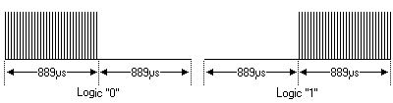The protocol uses bi-phase modulation (or so-called Manchester coding) of a 36kHz IR carrier frequency. All bits are of equal length of 1.778ms in this protocol, with half of the bit time filled with a burst of the 36kHz carrier and the other half being idle. A logical zero is represented by a burst in the first half of the bit time. A logical one is represented by a burst in the second half of the bit time. The pulse/pause ratio of the 36kHz carrier frequency is 1/3 or 1/4 which reduces power consumption.

|  |
| --- |
| Protocol |

The drawing below shows a typical pulse train of an RC-5 message. This example transmits command $35 to address $05.

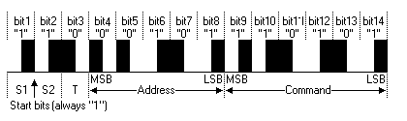

The first two pulses are the start pulses, and are both logical "1". Please note that half a bit time is elapsed before the receiver will notice the real start of the message.   
Extended RC-5 uses only one start bit. Bit S2 is transformed to command bit 6, providing for a total of 7 command bits. The value of S2 must be inverted to get the 7th command bit though!

The 3rd bit is a toggle bit. This bit is inverted every time a key is released and pressed again. This way the receiver can distinguish between a key that remains down, or is pressed repeatedly.   
The next 5 bits represent the IR device address, which is sent with MSB first. The address is followed by a 6 bit command, again sent with MSB first.   
A message consists of a total of 14 bits, which adds up to a total duration of 25 ms. Sometimes a message may appear to be shorter because the first half of the start bit S1 remains idle. And if the last bit of the message is a logic "0" the last half bit of the message is idle too.

As long as a key remains down the message will be repeated every 114ms. The toggle bit will retain the same logical level during all of these repeated messages. It is up to the receiver software to interpret this auto repeat feature.

PS: I had rather a big error on this page for quite some time. For some mysterious reason the LSB and MSB of the address and command were reversed. I can recall correcting this error before, but somehow an old version of the description must have sneaked its way up to the internet again.

|  |
| --- |
| Pre-defined Commands |

Philips has created a beautiful list of "standardized" commands. This ensures the compatibility between devices from the same brand.   
A very nice feature, often to be missed with other brands, is the fact that most devices are available twice in the table allowing you to have 2 VCRs stacked on top of each other without having trouble addressing only one of them with your remote control.   
I can only show a limited list of standard commands, for this list is about all I know right now.

|  |  |  |  |  |  |  |  |  |  |  |  |  |  |  |  |  |  |  |  |  |  |  |  |  |  |  |  |  |  |  |  |  |  |  |  |  |  |  |  |  |  |  |  |  |  |  |  |  |  |  |  |  |  |  |  |  |  |  |  |  |  |  |  |  |  |  |  |  |  |  |  |  |  |  |  |  |  |  |  |  |  |  |  |  |  |  |  |  |  |  |  |  |  |  |  |  |  |  |  |  |  |  |  |  |  |  |  |  |  |  |  |  |  |  |  |  |  |  |  |  |  |  |  |  |  |  |  |  |  |  |  |  |  |  |  |  |  |  |  |  |  |  |  |
| --- | --- | --- | --- | --- | --- | --- | --- | --- | --- | --- | --- | --- | --- | --- | --- | --- | --- | --- | --- | --- | --- | --- | --- | --- | --- | --- | --- | --- | --- | --- | --- | --- | --- | --- | --- | --- | --- | --- | --- | --- | --- | --- | --- | --- | --- | --- | --- | --- | --- | --- | --- | --- | --- | --- | --- | --- | --- | --- | --- | --- | --- | --- | --- | --- | --- | --- | --- | --- | --- | --- | --- | --- | --- | --- | --- | --- | --- | --- | --- | --- | --- | --- | --- | --- | --- | --- | --- | --- | --- | --- | --- | --- | --- | --- | --- | --- | --- | --- | --- | --- | --- | --- | --- | --- | --- | --- | --- | --- | --- | --- | --- | --- | --- | --- | --- | --- | --- | --- | --- | --- | --- | --- | --- | --- | --- | --- | --- | --- | --- | --- | --- | --- | --- | --- | --- | --- | --- | --- | --- | --- | --- | --- | --- |
| |  |  | | --- | --- | | **RC-5 Address** | **Device** | | $00 - 0 | TV1 | | $01 - 1 | TV2 | | $02 - 2 | Teletext | | $03 - 3 | Video | | $04 - 4 | LV1 | | $05 - 5 | VCR1 | | $06 - 6 | VCR2 | | $07 - 7 | Experimental | | $08 - 8 | Sat1 | | $09 - 9 | Camera | | $0A - 10 | Sat2 | | $0B - 11 |  | | $0C - 12 | CDV | | $0D - 13 | Camcorder | | $0E - 14 |  | | $0F - 15 |  | | $10 - 16 | Pre-amp | | $11 - 17 | Tuner | | $12 - 18 | Recorder1 | | $13 - 19 | Pre-amp | | $14 - 20 | CD Player | | $15 - 21 | Phono | | $16 - 22 | SatA | | $17 - 23 | Recorder2 | | $18 - 24 |  | | $19 - 25 |  | | $1A - 26 | CDR | | $1B - 27 |  | | $1C - 28 |  | | $1D - 29 | Lighting | | $1E - 30 | Lighting | | $1F - 31 | Phone | |  | |  |  |  | | --- | --- | --- | | **RC-5 Command** | **TV Command** | **VCR Command** | | $00 - 0 | 0 | 0 | | $01 - 1 | 1 | 1 | | $02 - 2 | 2 | 2 | | $03 - 3 | 3 | 3 | | $04 - 4 | 4 | 4 | | $05 - 5 | 5 | 5 | | $06 - 6 | 6 | 6 | | $07 - 7 | 7 | 7 | | $08 - 8 | 8 | 8 | | $09 - 9 | 9 | 9 | | $0A - 10 | -/-- | -/-- | | $0C - 12 | Standby | Standby | | $0D - 13 | Mute |  | | $10 - 16 | Volume + |  | | $11 - 17 | Volume - |  | | $12 - 18 | Brightness + |  | | $13 - 19 | Brightness - |  | | $20 - 32 | Program + | Program + | | $21 - 33 | Program - | Program - | | $32 - 50 |  | Fast Rewind | | $34 - 52 |  | Fast Forward | | $35 - 53 |  | Play | | $36 - 54 |  | Stop | | $37 - 55 |  | Recording | |

|  |
| --- |
| **NEC Protocol** |

To my knowledge the protocol I describe here was developed by NEC. I've seen very similar protocol descriptions on the internet, and there the protocol is called Japanese Format.   
I do admit that I don't know exactly who developed it. What I do know is that it is used in my late VCR produced by Sanyo and was marketed under the name of Fisher. NEC manufactured the remote control IC.   
This description was taken from the VCR's service manual. Those were the days, when service manuals were fulled with useful information!

|  |
| --- |
| Features |

* 8 bit address and 8 bit command length
* Address and command are transmitted twice for reliability
* Pulse distance modulation
* Carrier frequency of 38kHz
* Bit time of 1.125ms or 2.25ms

|  |
| --- |
| Modulation |

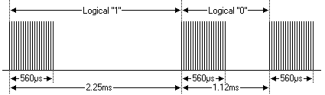The NEC protocol uses pulse distance encoding of the bits. Each pulse is a 560µs long 38kHz carrier burst (about 21 cycles). A logical "1" takes 2.25ms to transmit, while a logical "0" is only half of that, being 1.125ms. The recommended carrier duty-cycle is 1/4 or 1/3.

|  |
| --- |
| Protocol |

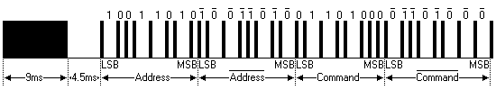

The picture above shows a typical pulse train of the NEC protocol. With this protocol the LSB is transmitted first. In this case Address $59 and Command $16 is transmitted. A message is started by a 9ms AGC burst, which was used to set the gain of the earlier IR receivers. This AGC burst is then followed by a 4.5ms space, which is then followed by the Address and Command. Address and Command are transmitted twice. The second time all bits are inverted and can be used for verification of the received message. The total transmission time is constant because every bit is repeated with its inverted length. If you're not interested in this reliability you can ignore the inverted values, or you can expand the Address and Command to 16 bits each!

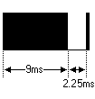

A command is transmitted only once, even when the key on the remote control remains pressed. Every 110ms a repeat code is transmitted for as long as the key remains down. This repeat code is simply a 9ms AGC pulse followed by a 2.25ms space and a 560µs burst.

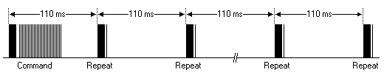

|  |
| --- |
| Extended NEC protocol |

The NEC protocol is so widely used that soon all possible addresses were used up. By sacrificing the address redundancy the address range was extended from 256 possible values to approximately 65000 different values. This way the address range was extended from 8 bits to 16 bits without changing any other property of the protocol.   
The command redundancy is still preserved. Therefore each address can still handle 256 different commands.

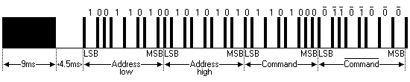

Keep in mind that 256 address values of the extended protocol are invalid because they are in fact normal NEC protocol addresses. Whenever the low byte is the exact inverse of the high byte it is not a valid extended address.

|  |
| --- |
| External Links |

[NEC Electronics](http://www.necel.com/en/faq/mi_com/__com_remo.html)

|  |
| --- |
| Example Commands |

The table below lists the messages sent by the remote control of my late Fisher 530 VCR (it served us well during its 20 years long life).

|  |  |
| --- | --- |
| **NEC Message** | **Key Function** |
| $68-$00 | Play |
| $68-$01 | Rec |
| $68-$02 | Audio Dub |
| $68-$03 | Frame Adv |
| $68-$04 | Slow |
| $68-$05 | Quick |
| $68-$06 | Cue |
| $68-$07 | Review |
| $68-$08 | FF |
| $68-$09 | Rew |
| $68-$0A | Stop |
| $68-$0B | Pause/Still |
| $68-$0C | Up key |
| $68-$1E | Down key |

|  |
| --- |
| **Sony SIRC Protocol** |

I've collected and combined some information found on the internet about the Sony SIRC protocol. I must admit that I have never worked with this particular protocol, so I could not verify that all information is valid for all situations.   
It appears that 3 versions of the protocol exist: 12-bit (described on this page), 15-bit and 20-bit versions. I can only assume that the 15-bit and 20-bit versions differ in the number of transmitted bits per command sequence.

Please note that a lot of confusing documentation about the SIRC protocol exists on the internet. At first I contributed to the confusion by assuming the correctness of the source documents I found myself, until someone with some SIRC experience informed me about my errors. I double checked his story with a universal remote control and a digital storage oscilloscope, and found that the bit and word order I documented were indeed wrong.   
The protocol information on this page is according to my own measurements and should be correct now.

|  |
| --- |
| Features |

* 12-bit, 15-bit and 20-bit versions of the protocol exist (12-bit described here)
* 5-bit address and 7-bit command length (12-bit protocol)
* Pulse width modulation
* Carrier frequency of 40kHz
* Bit time of 1.2ms or 0.6ms

|  |
| --- |
| Modulation |

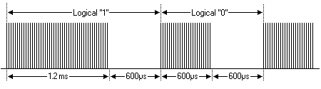The SIRC protocol uses a pulse width encoding of the bits. The pulse representing a logical "1" is a 1.2ms long burst of the 40kHz carrier, while the burst width for a logical "0" is 0.6ms long. All bursts are separated by a 0.6ms long space interval. The recommended carrier duty-cycle is 1/4 or 1/3.

|  |
| --- |
| Protocol |

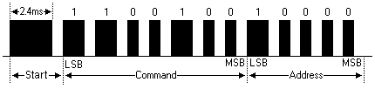

The picture above shows a typical pulse train of the SIRC protocol. With this protocol the LSB is transmitted first. The start burst is always 2.4ms wide, followed by a standard space of 0.6ms. Apart from signalling the start of a SIRC message this start burst is also used to adjust the gain of the IR receiver. Then the 7-bit Command is transmitted, followed by the 5-bit Device address. In this case Address 1 and Command 19 is transmitted.

Commands are repeated every 45ms(measured from start to start) for as long as the key on the remote control is held down.

|  |
| --- |
| Example Commands |

The table below lists some messages sent by Sony remote controls in the 12-bit protocol. This list is by no means meant to be complete, as the assignment of functions is probably quite dynamic.

|  |  |  |  |  |  |  |  |  |  |  |  |  |  |  |  |  |  |  |  |  |  |  |  |  |  |  |  |  |  |  |  |  |  |  |  |  |  |  |  |  |  |  |  |  |  |  |  |  |  |  |  |  |  |  |  |  |  |  |  |  |  |  |  |  |  |  |  |  |  |  |  |  |  |  |  |  |
| --- | --- | --- | --- | --- | --- | --- | --- | --- | --- | --- | --- | --- | --- | --- | --- | --- | --- | --- | --- | --- | --- | --- | --- | --- | --- | --- | --- | --- | --- | --- | --- | --- | --- | --- | --- | --- | --- | --- | --- | --- | --- | --- | --- | --- | --- | --- | --- | --- | --- | --- | --- | --- | --- | --- | --- | --- | --- | --- | --- | --- | --- | --- | --- | --- | --- | --- | --- | --- | --- | --- | --- | --- | --- | --- | --- | --- |
| |  |  | | --- | --- | | **Address** | **Device** | | 1 | TV | | 2 | VCR 1 | | 3 | VCR 2 | | 6 | Laser Disc Unit | | 12 | Surround Sound | | 16 | Cassette deck / Tuner | | 17 | CD Player | | 18 | Equalizer | |  | |  |  | | --- | --- | | **Command** | **Function** | | 0 | Digit key 1 | | 1 | Digit key 2 | | 2 | Digit key 3 | | 3 | Digit key 4 | | 4 | Digit key 5 | | 5 | Digit key 6 | | 6 | Digit key 7 | | 7 | Digit key 8 | | 8 | Digit key 9 | | 9 | Digit key 0 | | 16 | Channel + | | 17 | Channel - | | 18 | Volume + | | 19 | Volume - | | 20 | Mute | | 21 | Power | | 22 | Reset | | 23 | Audio Mode | | 24 | Contrast + | | 25 | Contrast - | | 26 | Colour + | | 27 | Colour - | | 30 | Brightness + | | 31 | Brightness - | | 38 | Balance Left | | 39 | Balance Right | | 47 | Standby | |

|  |
| --- |
| **Philips RC-6 Protocol** |

RC-6 is, as may be expected, the successor of the RC-5 protocol. Like RC-5 the new RC-6 protocol was also defined by Philips. It is a very versatile and well defined protocol. Because of this versatility its original definition is many pages long. Here on my page I will only summarize the most important properties of this protocol.

|  |
| --- |
| Features |

* Different modes of operation, depending on the intended use
* Dedicated Philips modes and OEM modes
* Variable command length, depending on the operation mode
* Bi-phase coding (aka Manchester coding)
* Carrier frequency of 36kHz
* Manufacturer Philips

|  |
| --- |
| Modulation |

RC-6 signals are modulated on a 36 kHz Infra Red carrier. The duty cycle of this carrier has to be between 25% and 50%.

Data is modulated using Manchester coding. This means that each bit (or symbol) will have both a mark and space in the output signal. If the symbol is a "1" the first half of the bit time is a mark and the second half is a space. If the symbol is a "0" the first half of the bit time is a space and the second half is a mark.   
Please note that this is the opposite of the RC-5 protocol!

The main timing unit is 1t, which is 16 times the carrier period (1/36k * 16 = 444µs).

With RC-6 a total of 5 different symbols are defined:

* The leader pulse, which has a mark time of 6t (2.666ms) and a space time of 2t (0.889ms). This leader pulse is normally used to set the gain of the IR receiver unit.   
  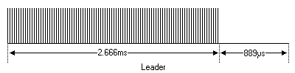
* Normal bits, which have a mark time of 1t (0.444ms) and space time of 1t (0.444ms). A "0" and "1" are encoded by the position of the mark and space in the bit time.   
  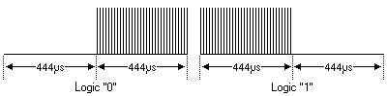
* Trailer bits, which have a mark time of 2t (0.889ms) and a space time of 2t (0.889ms). Again a "0" and "1" are encoded by the position of the mark and space in the bit time.   
  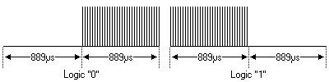

The leader and trailer symbols are only used in the header field of the messages, which will be explained in more detail below.

|  |
| --- |
| RC-6 Mode 0 |

I can only describe operation mode 0 because I have never actually seen other modes in use than the one my Philips TV understands. The way I understand it the other modes can vary extremely from mode 0.

Mode 0 is a dedicated Philips Consumer Electronics mode. It allows control of up to 256 independent devices, with a total of 256 commands per device.

RC-6 Mode 0

The command is a concatenation of different information. I will cover these different components from left to right.

**Header field**

The Header field consists of 3 different components.

* First the leader symbol LS is transmitted. Its purpose is to adjust the gain of the IR receiving unit.
* This leader symbol is followed by a start bit SB which always has the value "1". Its purpose is to calibrate the receiver's timing.
* The mode bits mb2 ... mb0 determine the mode, which is 0 in this case, thus all three bits will be "0".
* Finally the header is terminated by the trailer bit TR. Please note that the bit time of this symbol is twice as long as normal bits! This bit also serves as the traditional toggle bit, which will be inverted whenever a key is released. This allows the receiver to distinguish between a new key or a repeated key.

**Control Field**

This field holds 8 bits which are used as address byte. This means that a total of 256 different devices can be controlled using mode 0 of RC-6.   
The msb is transmitted first.

**Information Field**

The information field holds 8 bits which are used as command byte. This means that each device can have up to 256 different commands.   
The msb is transmitted first.

**Signal Free Time**

The Signal Free time is a period in which no data may be transmitted (by any device). It is important for the receiver to detect the signal free time at the end of a message to avoid incorrect reception.   
The signal free time is set to 6t, which is 2.666ms.

|  |
| --- |
| **RCA Protocol** |

Here's a contribution from one of my visitors, [Pablot](http://pablot.com) from Sweden. He generously composed the information on this page. Here is what he wrote:   
There is not much info out there about the RCA protocol so I basically took a remote (an XBOX remote that uses the RCA protocol) and started analyzing the flow. I also had help from looking at the [lirc remote archive](http://lirc.org/remotes/RCA). I then concluded my best guess (nothing confirmed). It is actually quite similar to the NEC protocol.

|  |
| --- |
| Features |

* 12-bit protocol
* 4-bit address and 8-bit command length (12-bit protocol)
* Pulse distance modulation
* Carrier frequency of 56kHz
* Bit time of 1.5ms or 2.5ms
* Complement of code sent out after real code for reliability

|  |
| --- |
| Modulation |

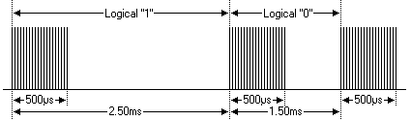The RCA protocol uses pulse distance encoding of the bits. Each pulse is a 500µs long 56kHz carrier burst (28 cycles). A logical "1" takes 2.5ms to transmit, while a logical "0" is only 1.5ms.

|  |
| --- |
| Protocol |

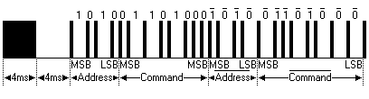

The picture above shows a typical pulse train of the RCA protocol. With this protocol the MSB is transmitted first. In this case Address $A and Command $68 is transmitted. A message is started by a 4ms AGC burst, which was used to set the gain of the earlier IR receivers. This AGC burst is then followed by a 4ms space, which is then followed by the Address and Command. Address and Command are transmitted twice. The second time all bits are inverted and can be used for verification of the received message. The total transmission time is constant because every bit is repeated with its inverted length. If you're not interested in this reliability you can ignore the inverted values.

Commands are repeated every 64ms(measured from start to start) for as long as the key on the remote control is held down.